**HOSPITAL MANAGEMENT SYSTEM**

This guide will help the student to create a database on the Hospital Management System. It will help to manage the below functionalities.

* Patient details
* Doctors details
* Appoindetails details
* Medicines detail
* Prescriptions

-- Create the Patients table

CREATE TABLE Patients (

PatientID INT PRIMARY KEY,

FirstName VARCHAR(50),

LastName VARCHAR(50),

Gender CHAR(1),

DateOfBirth DATE,

PhoneNumber VARCHAR(15),

Email VARCHAR(100),

Address VARCHAR(255)

);

-- Create the Doctors table

CREATE TABLE Doctors (

DoctorID INT PRIMARY KEY,

FirstName VARCHAR(50),

LastName VARCHAR(50),

Gender CHAR(1),

DateOfBirth DATE,

PhoneNumber VARCHAR(15),

Email VARCHAR(100),

Specialization VARCHAR(100)

);

-- Create the Appointments table

CREATE TABLE Appointments (

AppointmentID INT PRIMARY KEY,

PatientID INT,

DoctorID INT,

AppointmentDate DATETIME,

Diagnosis VARCHAR(255),

Prescription VARCHAR(255),

FOREIGN KEY (PatientID) REFERENCES Patients(PatientID),

FOREIGN KEY (DoctorID) REFERENCES Doctors(DoctorID)

);

-- Create the Medicines table

CREATE TABLE Medicines (

MedicineID INT PRIMARY KEY,

MedicineName VARCHAR(100),

Manufacturer VARCHAR(100),

ExpiryDate DATE,

Price DECIMAL(10, 2)

);

-- Create the Prescriptions table

CREATE TABLE Prescriptions (

PrescriptionID INT PRIMARY KEY,

AppointmentID INT,

MedicineID INT,

Dosage VARCHAR(50),

Quantity INT,

FOREIGN KEY (AppointmentID) REFERENCES Appointments(AppointmentID),

FOREIGN KEY (MedicineID) REFERENCES Medicines(MedicineID)

);

VALUES INSERTING IN DATA BASE

-- Insert values into the Patients table

INSERT INTO Patients (PatientID, FirstName, LastName, Gender, DateOfBirth, PhoneNumber, Email, Address)

VALUES

(1, 'John', 'Doe', 'M', '1980-05-15', '1234567890', 'john.doe@example.com', '123 Main St'),

(2, 'Jane', 'Smith', 'F', '1985-08-20', '9876543210', 'jane.smith@example.com', '456 Oak Ave');

-- Insert values into the Doctors table

INSERT INTO patients (PatientID, FirstName, LastName, Gender, DateOfBirth, PhoneNumber, Email, Address)

VALUES (1, 'john', 'Doe', 'M', '1980-05-15', '1234567890', 'yogee.doe@example.com', '123 Main St');

(2, 'Jane', 'Smith', 'F', '1985-08-20', '9876543210', 'jeni.smith@example.com', '454 Oak Ave');

-- Insert values into the Doctors table

INSERT INTO doctors (DoctorID, FirstName, LastName, Gender, DateOfBirth, PhoneNumber, Email, Specialization)

VALUES(101, 'Dr. Yogesh', 'Waran', 'M', '1975-02-10', '5551234567', 'yogesh.j@example.com', 'Cardiology'),

(102, 'Dr. Ramya', 'Williams', 'F', '1982-07-25', '5559876543', 'ramya.w@example.com', 'Pediatrics');

-- Insert values into the Appointments table

INSERT INTO appointments (AppointmentID, PatientID, DoctorID, AppointmentDate, Diagnosis, Prescription)

VALUES(1001, 1, 101, '2024-03-01 09:00:00', 'Hypertension', 'Prescribe medication'),

(1002, 2, 102, '2024-03-02 10:30:00', 'Common cold', 'Rest and fluids');

-- Insert values into the Medicines table

INSERT INTO medicines (MedicineID, MedicineName, Manufacturer, ExpiryDate, Price)

VALUES(201, 'Aspirin', 'ABC Pharma', '2025-12-31', 5.99),

(202, 'Cough Syrup', 'XYZ Meds', '2024-08-15', 8.50);

-- Insert values into the Prescriptions table

INSERT INTO prescriptions (PrescriptionID, AppointmentID, MedicineID, Dosage, Quantity)

VALUES(5001, 1001, 201, 'Take one tablet daily', 30),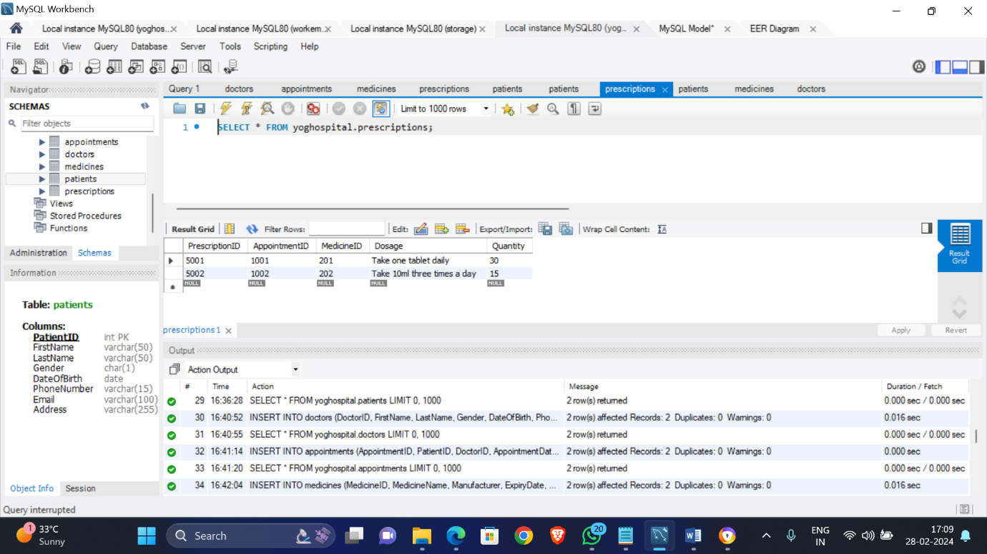

(5002, 1002, 202, 'Take 10ml three times a day', 15);